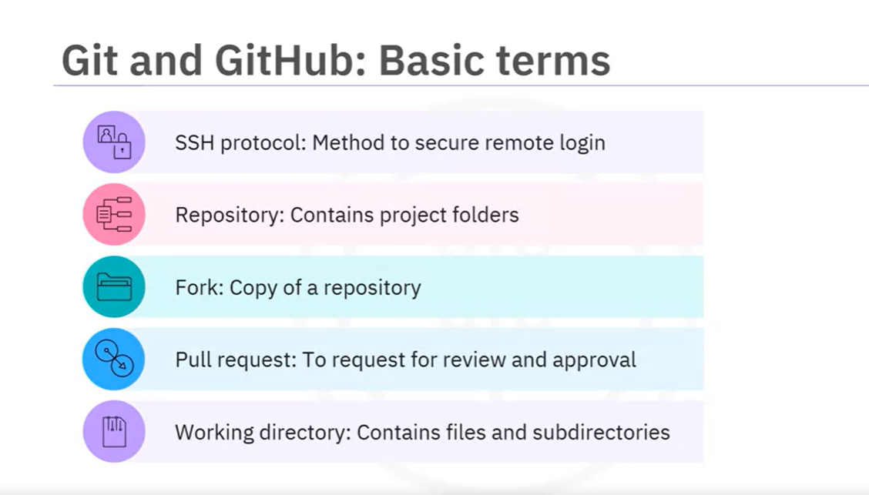

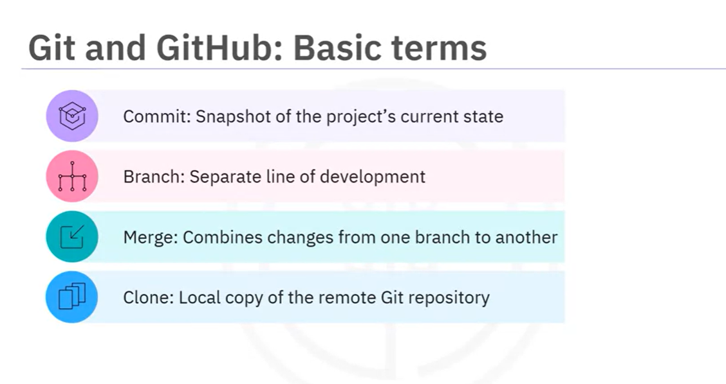

**1.**

Question 1

What is the relation between Git and GitHub?

1 / 1 point



GitHub is an online hosting service for Git repositories.

Correct

Correct! GitHub is one of the most popular web-hosted services for Git repositories.

**2.**

Question 2

Which of the following describes a repository?

1 / 1 point



A data structure that stores documents and source code

Correct

Correct! A repository is a data structure for storing documents, including application source code.

**3.**

Question 3

What is the purpose of a license?

1 / 1 point



To express how people can use your code

Correct! The purpose of a license file is to express how people can use your code.

**4.**

Question 4

What is the role of “commit” in GitHub?

1 / 1 point



To save changes

Correct

Correct! To save your changes to a GitHub repository, you must commit the changes.

**5.**

Question 5

What type of version control system is Git?

1 / 1 point



Distributed

Correct

Correct! Git is a distributed version control system, meaning each team member has a copy of the entire project, including its files and revision history, on their computer.

**6.**

Question 6

Which of the following statements is associated with a working directory?



Contains the files and subdirectories on the computer that are associated with a Git repository

Correct

Correct! A working directory contains the files and subdirectories on your computer that are associated with a Git repository.

**7.**

Question 7

What happens if you make a change on a repository branch that you don't own?



GitHub makes a pull request

WEEK 3

### 1.

Question 1

What is meant by an initial commit in a Git workflow?



Officially recording the current state of your project’s files in the local Git repository

Correct

Correct! An initial commit is the process of officially recording and saving the current state of your project’s files in the local Git repository. This step marks the starting point of your project’s version history.

### 2.

Question 2

Which git command allows you to see the state of your working directory and the staged snapshot of your changes?

1 / 1 point



git status

Correct

Correct! The git status command allows you to see the state of your working directory and the staged snapshot of your changes.

### 3.

Question 3

Why do you fork a project?



To use an existing repository as the base for a new project

Correct

Correct! Forking allows you to modify or extend a repository without affecting the original repository. Frequently, developers use forking to make an existing repository the starting point of your new project.

### 4.

Question 4

Which of the following options should be used to fork a repository?



Navigate to the GitHub project and select Fork at the top of the page.

Correct

Correct! There are no Git commands used for forking a project. You can fork it by navigating to the GitHub project and selecting the Fork option.

### 5.

Question 5

Which Git command can an integrator use to undo any botched commits?



git revert

Correct

Correct! An integrator can use git-revert command to undo any botched commits.